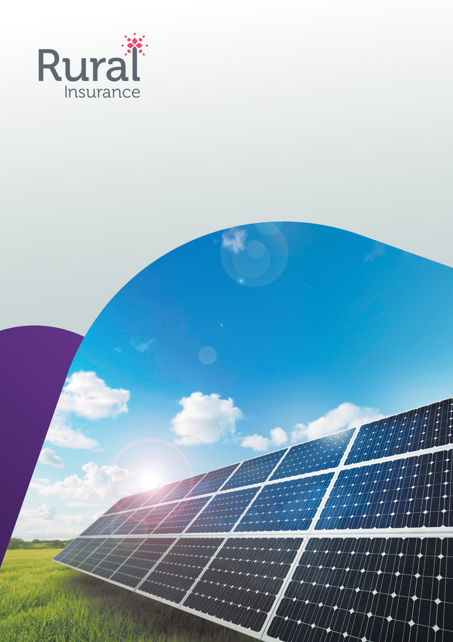
Micro Photovoltaic
Proposal form
1 Title of contract
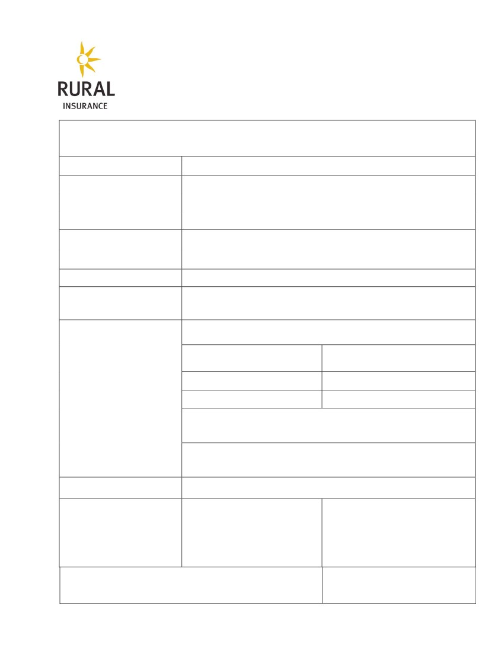Questionnaire for Micro Photovoltaics Insurance
Click within the space to insert required information. Insert ‘X’ in appropriate box where appropriate
2 Location of erection site
Postcode
City, town, village
3 Principal
Name and address
4 Clients Occupancy
5 If client is renting roof space
for the operation of PV,
occupancy of lessor
6 Main contractor(s) /
Manufacturer(s) of main items
6.1 Manufacturers Name(s)
6.2 Capacity of Panels and
Transformer
Total Installation Output /
Capacity:
6.3 Are the panels certificated
under IEC 61215 ?
Panels:
Type:
Panels (kW):
Converter ,Transformer or Inverter:
Transformer: MVA
Date Commissioned:
O
yes
O no
6.4 Is a Tracking/Follower System
in place?
7 Period of insurance
8 Have plans, designs and
materials of the kind used in this
project been used and/ or tested
in previous constructions?
If no, please give details
O
yes
O no
Commencement of insurance:
O yes
/ O no
9
Are the Panels ground mounted or roof mounted?
O
O
Ground Mounted
Roof Mounted
Rural Insurance Group Limited is authorised and regulated by the Financial Conduct Authority. Registered address: The Hamlet, Hornbeam Park, Harrogate HG2 8RE
Registered in England and Wales. Registered no. 2207611. Version 26.01.2015

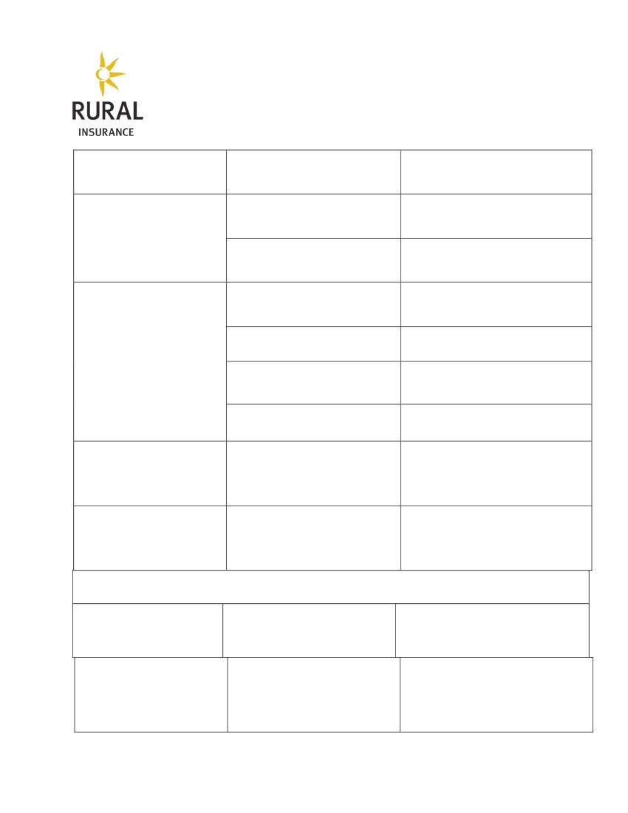
10 If the Panels are Roof mounted
10.1 Is the building of standard brick/steel
frame construction?
O yes
O no
10.2 Is the building timber framed or
clad?
O yes
O no
10.3 Does the building contain flammable
material (i.e. hay, fertiliser etc)?
11
If the Panels are ground
mounted
O yes
O no
11.1 Are they protected by a fence
with a minimum height of 2.00 m
11.2 What additional theft protection in
in place (please give description)
11.3 What precautions do you take to
cut vegetation to protect the panels
from fire ?
(please give description)
11.4 Is there a history of flooding at the
site?
Is the protection against lightning and
over voltage based on IEC 61 024 ,
DIN/VDE 0185 or alternative standard?
If no, give details
O yes
O no
O yes
O no
O yes
O no
12 Lightning and Over Voltage
13 Claims History
Please provide details of any claims or
losses in the last 3 years
14 Sums to be insured and Deductibles
Please state here under the amounts you wish to insure or where applicable
Section I -
Material damage
Sums to be insured
Excess
£
Sums to be insured (annual income)
£1,000
£2,500
£5,000
Section 2 –
Business Interruption
Indemnity Period
Excess Period
£
Rural Insurance Group Limited is authorised and regulated by the Financial Conduct Authority. Registered address: The Hamlet, Hornbeam Park, Harrogate HG2 8RE
Registered in England and Wales. Registered no. 2207611. Version 26.01.2015
3 mths
5 days
6 mths
10 days
12 mths
20 days


Annual electricity production and
feed-in-tariff
kWh: …………
Tariff: …….
£

Rural Insurance Group Limited is authorised and regulated by the Financial Conduct Authority.
Registered address: The Hamlet, Hornbeam Park, Harrogate HG2 8RE. Registered in England and Wales. Registered no. 2207611
Rural Insurance Group Limited
The Hamlet
Hornbeam Park
Harrogate
HG2 8RE

T: 0344 55 77 177
F: 01423 876 001
E: enquiries@ruralinsurance.co.uk
W: ruralinsurance.co.uk


