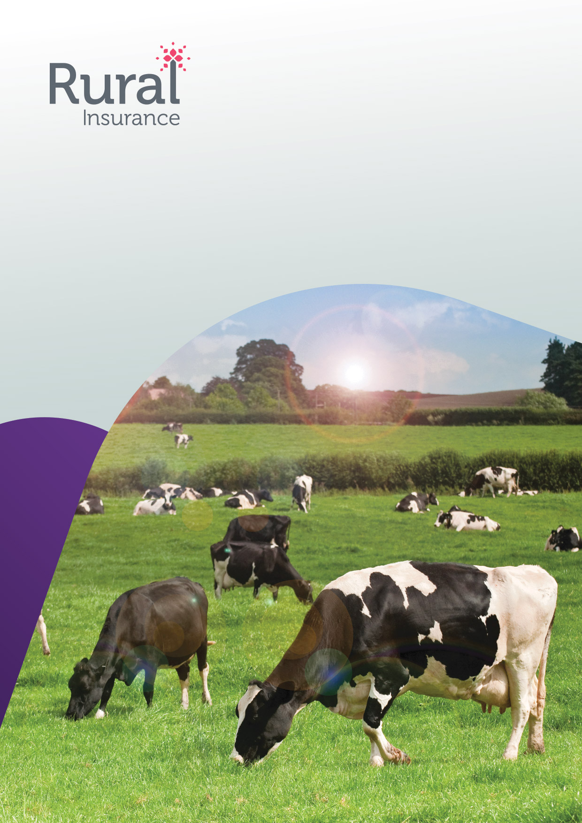
Livestock
Proposal form

Tel: 0344 55 77 177
Rural
The Hamlet
Hornbeam Park
Harrogate HG2 8RE
Fax: 01423 876001
PLEASE READ THE FOLLOWING IMPORTANT NOTES BEFORE COMPLETING THIS PROPOSAL
PLEASE ENSURE THAT YOU COMPLETE THIS FORM FULLY, CORRECTLY AND DISCLOSE ALL FACTS LIKELY TO INFLUENCE THE
ACCEPTANCE OF THIS PROPOSAL.
SHOULD YOU HAVE ANY DOUBTS WHETHER OR NOT A FACT IS RELEVANT, YOU SHOULD DISCLOSE IT. OMISSION OR
MIS-STATEMENT MAY AFFECT THE SETTLEMENT OF CLAIMS UNDER THIS POLICY OR MAKE THE POLICY INVALID.
Livestock Proposal
QUOTE REFERENCE:
GENERAL INFORMATION
Full Name
Address
Home Tel. No.
Work Tel. No.
Trading name (if different from above)
Date cover to commence. From
Description of all occupations
Address of Farm/Estate/Grass keep if different
Tel. No.
GENERAL INFORMATION (Insert ‘X’ where appropriate)
1.
2.
3.
4.
5.
6.
Has the proposer ever had insurance for the risks proposed?
Has an insurer ever terminated, declined or refused renewal or an insurance or
imposed special conditions or requested an increased premium?
Are all your Livestock sound, healthy and free from defects?
Have any of your Livestock suffered illness, injury or disease?
Has the proposer any other Livestock of the same class which are not to be insured?
Has the proposer suffered any loss with respect to his Livestock during the last five years?
If ‘Yes’, please provide dates, costs and circumstances of each loss below:
Yes
Yes
Yes
Yes
Yes
Yes
No
No
No
No
No
No
Livestock Insurance Proposal . Version 8 . Feb 20
1 of 12


PLEASE INSERT ‘X’ IN THE BOX FOR THE SECTIONS REQUIRED
INDIVIDUAL RISKS
1. Specified animals - All risks Mortality
2. Specified animals - Accidental death only
3. Prospective calf
4. Fertility guarantee
5. Infertility
HERD/FLOCKS RISKS
6. Tuberculosis
7. Anthrax
8. Brucellosis
9. Foot and Mouth
10. Swine Vesicular Disease
11. Aujeszky Disease
12. European Swine Fever
13. Maedi Visni
SPECIFIED ANIMALS
1. ALL RISKS MORTALITY 2. ACCIDENTAL DEATH 3. PROSPECTIVE CALF
4. FERTILITY 5. FERTILITY GUARANTEE 6. INFERTILITY
DEATH DUE TO ACCIDENT, ILLNESS OR DISEASE (INCLUDING TB, ANTHRAX AND JOHNE’S DISEASE)
TYPE, BREED &
COLOUR
AGE
(RISING)
NAME OR
REF No
PURPOSE
OR USE
IF PREGNANT
DATE DUE TO
CALVE/LAMB
SEX
PRICE
PAID
MARKET
VALUE
SUM TO BE
INSURED
APPLICABLE TO SECTIONS 1 & 2
PLEASE NOTE*: IF THE SUM TO BE INSURED EXCEEDS £2,000 (CATTLE) OR £1,000 (SHEEP), THE APPROPRIATE
VETERINARY CERTIFICATE AT THE BACK OF THIS PROPOSAL FORM MUST BE COMPLETED.
Are any of the animals hired out?
If ‘Yes’ please provide full details
Yes
No
*If infertility cover is required the vets certificate at the back of this form must be completed in all cases.
2 of 12
Livestock Insurance Proposal . Version 8. Feb 20


APPLICABLE TO SECTION 1 ONLY
1. Do you require cover against permanent infertility/loss of use on bulls/rams?
2. In the case of dogs, have the animals been inoculated against distemper/hard pad?
3. In the case of rams, the sum insured will normally be reduced
by 50% outside the service season. Please specify the dates
during which the service season normally runs?
Yes
Yes
No
No
APPLICABLE TO SECTION 4 - FERTILITY GUARANTEE
1. Address of Mart/Farm at which sale took place
2. Date of sale
3. Was the sale a recognised Breed Society catalogue sale?
4. Is the Fertility Guarantee given to the purchaser in accordance
with the standard Breed Society guarantee?
If ‘No’ please specify amendments
Yes
Yes
No
No
HERD/FLOCK RISKS
SECTION 6 - TUBERCULOSIS REACTOR TESTS
No & TYPE OF
ANIMALS
PURPOSE OF USE
TOTAL VALUE
*MAXIMUM VALUE
PER HEAD
SUM INSURED
*Please Note:
If the maximum value per head exceeds £2,000 please attach list giving identification number and market value of each animal.
Please also complete the Declaration at the back of this form
Livestock Insurance Proposal . Version 8 . Feb 20
3 of 12


SECTION 7 - ANTHRAX
No & TYPE OF
ANIMALS
PURPOSE OF USE
TOTAL VALUE
*MAXIMUM VALUE
PER HEAD
SUM INSURED
*Please Note:
If the maximum value per head exceeds £2,000 please attach list giving identification number and market value of each animal.
SECTION 8 - BRUCELLOSIS REACTOR (ERADICATION SCHEME)
1. To pay difference between MAFF compensation and actual market value, plus 25% of
DEFRA compensation. Maximum value any one animal £2,000. Total value at risk:
2. Specify any animals valued in excess of £2,000
3. Date accredited/certified
4. Accredited/certified herd Reference No.
5. Has there been a blood test subsequent to accreditation/certification
during the past three years at which a reactor has been revealed?
If ‘Yes’ please state:
Date of test
Number of animals tested
Number of reactors
Date movement restrictions lifted
6. Please state:
Date of last test
Number of animals tested
Date of next test
7. Is your herd a dealer’s herd?
8. Has any animal aborted or calved prematurely during the last three months?
If ‘Yes’ please give details
9. Give brief details of movements into the herd in the last twelve months
Yes
Yes
No
No
Yes
No
£
10. State locality from which the animals originated
11. To the best of your knowledge, has Brucellosis been diagnosed
within a five mile radius of your farm?
If ‘Yes’ please give details
Yes
No
4 of 12


SECTION 9 - FOOT & MOUTH
A. To pay 25% of DEFRA compensation or 25% of market value, whichever is the lower
No OF
HEAD
PLEASE STATE PERCENTAGE
INDEMNITY REQUIRED
IF MORE THAN 25%
TYPE OF STOCK
MARKET VALUE
B. To pay specified percentage of total value of herd on a monthly basis during infected period (maximum)
PLEASE STATE PERCENTAGE
INDEMNITY REQUIRED
IF MORE THAN 25%
TYPE OF STOCK
INDEMNITY
Please also complete the Supplementary Questionaire at the back of this form
SECTION 10 - SWINE VESICULAR DISEASE
To pay 25% of DEFRA compensation. N.B. No loss admissible within 21 days of policy inception
SUM INSURED 25%
OF TOTAL VALUE
TYPE OF STOCK
BOARS
GILTS
SOWS
PORKER, STORES & YOUNGSTERS
1. Is your herd self contained?
If not:
What stock is brought in?
From where is it obtained?
NUMBER
TOTAL VALUE
Yes
No
How many pigs have been brought onto
the premises during the past 28 days?
What quarantine arrangements do
you have for pigs brought in?
2. To the best of your knowledge, has there been an outbreak of Swine Vesicular Disease
during the past 28 days within 40 miles of your premises?
If ‘Yes’ please give details
Yes
No
Livestock Insurance Proposal . Version 8 . Feb 20
5 of 12


SECTION 11 - AUJESZKY’S DISEASE
STOCK
NUMBER
MAXIMUM VALUE PER HEAD
MARKET VALUE
BOARS
GILTS
SOWS
PORKER, STORES & YOUNGSTERS
1. Are you a member of The Pig Health Scheme or PCHA?
If ‘Yes’ when was the last
blood test carried out by
the MAFF?
2. What stock is brought
into the unit?
Yes
No
3. Is stock purchased exclusively from one source of supply?
If ‘Yes’ please state source:
Yes
No
4. Do you use one haulier exclusively?
If ‘Yes’ please give details:
Yes
No
5. Is the source of supply a member of The Pig Health Scheme?
6. From where do you
purchase feed?
Yes
No
7. Are all pigs housed indoors permanently?
If ‘No’ please give full details
Yes
No
8. Is there, to the best of your knowledge, an outbreak within a 10 mile radius of your premises? Yes
If ‘Yes’ please give full details
No
9. Have there been any clinical signs of Aujeszky’s Disease at your premises in the last 20 days?
If ‘Yes’ please give full details
Yes
No
6 of 12
Livestock Insurance Proposal . Version 8 . Feb 20


SECTION 12 - EUROPEAN SWINE FEVER
1. Please state the total value of animals to be insured
2. Have any of the animals to be insured been purchased in the open market?
If ‘Yes’ please give full details
£
Yes
No
3. Have any of the animals to be insured been fed swill or waste food?
If ‘Yes’ please give full details
Yes
No
SECTION 13 - MAEDI VISNI
1. Please state the total value of animals to be insured
2. Date of accreditation:
3. Date of last test:
4. Result of last test:
If ‘Positive’ please
give full details
Positive
Negative
£
Livestock Insurance Proposal . Version 8 . Feb 20
7 of 12


IMPORTANT
PLEASE NOTE THAT FAILURE TO DISCLOSE ALL MATERIAL FACTS WHICH UNDERWRITERS WOULD REGARD AS LIKELY TO
INFLUENCE THE ACCEPTANCE AND ASSESSMENT OF THIS PROPOSAL COULD INVALIDATE THE INSURANCE. IF YOU ARE IN
ANY DOUBT AS TO WHETHER A FACT IS MATERIAL, YOU SHOULD CONSULT YOUR BROKER AND DISCLOSE IT IN WRITING
ON A SEPARATE SHEET.
OUR LIABILITY DOES NOT COMMENCE UNTIL THIS PROPOSAL HAS BEEN ACCEPTED BY THE UNDERWRITERS . ANY
OCCURRENCE AFFECTING YOUR LIVESTOCK AFTER THE SIGNING OF THIS PROPOSAL AND BEFORE COVER COMMENCES
MUST BE DISCLOSED. WE RESERVE THE RIGHT TO ASK FOR SPECIAL TERMS OR TO DECLINE THIS PROPOSAL. YOU ARE
STRONGLY ADVISED TO KEEP A COPY OF THIS PROPOSAL AND ANY OF THE INFORMATION SUPPLIED FOR THE PURPOSE
OF ENTERING INTO THIS INSURANCE.
NOTICE
FOR THE PURPOSES OF THE DATA PROTECTION ACT 1998, THE DATA CONTROLLER IN RELATION TO ANY PERSONAL DATA
YOU SUPPLY IS RURAL INSURANCE GROUP LIMITED.
DECLARATION
I/WE CONFIRM THAT IT IS IN ORDER TO RELEASE TO RURAL INSURANCE GROUP LIMITED ANY INFORMATION THEY
REQUEST REGARDING MY/OUR PREVIOUS INSURANCE, INCLUDING CLAIMS HISTORY AND ANY SPECIAL TERMS OR
CONDITIONS IMPOSED.
I/WE DECLARE THAT TO MY/OUR KNOWLEDGE AND BELIEF THAT THE INFORMATION GIVEN IN THIS PROPOSAL FORM IS
TRUE AND COMPLETE. I/WE AGREE THAT THIS PROPOSAL AND DECLARATION SHALL BE THE BASIS OF THE CONTRACT
BETWEEN ME/US AND THE INSURERS.
Signature of
policyholder
Date
8 of 12
Livestock Insurance Proposal . Version 8 . Feb 20


VETERINARY SURGEON’S CERTIFICATE
Cattle & Sheep
Fees to be paid by owner
Address where animal(s) seen:
No & TYPE OF
ANIMALS
SEX
BREED
COLOUR &
DESCRIPTION
DATE OF
BIRTH
IDENTIFICATION
NUMBER
OWNERS ESTIMATE
OF VALUE
PLEASE ANSWER THE FOLLOWING QUESTIONS WHEN LOSS OF USE/INFERTILITY
COVER HAS BEEN REQUESTED UNDER SECTIONS ONE & FIVE:
1. Do the animals represent a normal breeding risk?
2. Are there any abnormal conditions affecting the genitalia or breeding organs?
If ‘Yes’ please give full details
Yes
Yes
No
No
3. Is there any other condition apparent which could affect the breeding ability?
If ‘Yes’ please give full details
Yes
No
I HEREBY CERTIFY THAT I HAVE THIS DAY EXAMINED THE SAID ANIMAL(S) DESCRIBED IN THE SCHEDULE AND IN MY
OPINION THE SAME ARE SOUND AND IN GOOD CONDITION AND THAT I KNOW OF NO REASON WHY INSURANCE
SHOULD NOT BE GRANTED. FURTHERMORE I HEREBY CERTIFY THAT NO INFORMATION WHICH OUGHT TO BE DISCLOSED
HAS BEEN WITHHELD.
Name & Address of
Veterinary Surgeon
Signature of
Veterinary Surgeon
Date
Livestock Insurance Proposal . Version 8 . Feb 20
9 of 12


TUBERCULOSIS DECLARATION
Proposers Name
1. Has any of the Proposers herd ever been tested positive in respect of Tuberculosis?
If ‘Yes’ please provide full details:
Yes
No
2. Have there been any Tuberculosis outbreaks in the last 12 months within a 10 mile radius?
If ‘Yes’ please provide full details:
Yes
No
3. Have you introduced any livestock within the last 12 months
If ‘Yes’:
When?
From where?
Were the animals tested negative for TB before they were introduced?
If ‘No’, please provide details:
Yes
No
Yes
No
4. Has any farm within a 10 mile radius had animals slaughtered as a result
of Foot and Mouth and subsequently been restocked?
If ‘Yes’, please advise approximate distance from your own farm:
Yes
No
5. Please confirm:
(a) The date of the last Tuberculosis test
(b) The result
(c) The testing programme i.e. 1,2 or 3 years
(d) The date of your next test
10 of 12
Livestock Insurance Proposal . Version 8 . Feb 20


SUPPLEMENTARY PROPOSAL FORM FOR FOOT AND MOUTH
If the space below is inadequate for your answer, please use another sheet of paper.
1.
Are there any major thoroughfares running through or bordering your farm(s)?
Please provide plan(s) of motorways, A roads and B roads.
2.
Give FULL details of ALL movements of the herd/flock in the last THREE months, stating the locality from which the
animals originated and place of purchase in each case.
3.
If your herd/flock is a closed herd/flock, how long has it been closed?
Yes
No
4. Does your land adjoin any other land with livestock?
If ‘Yes’, is the other livestock pigs, sheep, cattle, goats, or any other cloven hoofed animal?
Please provide details/plan below
5. What type of herd/flock do you have? e.g. pedigree, rare breeds
6. Please advise details of the nearest pig farm, if any?
7. Please provide exact details of the location of all your animals/farms, with a split in values/numbers for each farm
8. Please provide the number of animals of each type together with the sum insured
Type of animal
No. of animals
Sum Insured
Type of animal
No. of animals
Sum Insured
9. During the last outbreak, please provide proximity to:
(a) Infected farms
(b) Infected areas
give full details:
give full details:
Livestock Insurance Proposal . Version 8. Feb 20
11 of 12

Rural is a trading name of Geo Underwriting Services Limited which is authorised and regulated by the Financial Conduct Authority. FCA Register Number 308400. Registered address: 1 Minster Court, Mincing Lane, London, EC3R 7AA. Registered in England 04070987.
Rural
The Hamlet
Hornbeam Park
Harrogate
HG2 8RE

T: 0344 55 77 177
F: 01423 876 001
E: enquiries@ruralinsurance.co.uk
W: ruralinsurance.co.uk


